# Data cleaning for UK events dataset

ukEvents dataset is extracted using Python into a comma-separated file called ukEvents.csv. First, the data is manually observed, and the data errors classified. Then the data is cleaned using Manual Intervention and Automatic Correction.

## Data Error Classification

**(a) Incomplete/missing values**

**(b) Corrupted values**

**(c) Out of range values**

**(d) Wrong data**

**(e) Duplicate data**

**(f) Other errors – a comma in the field treated by the database as a delimiter.**

## Cleaning stages

**(1) Using Microsoft Excel remove all commas (,) and double quotation marks (“) as shown in figures 1, 2, 3, and 4 below.**

**(2) Using Python Pandas Dataframe missing and duplicate data handling, automate the replacement of missing data in each field.**

## Data quality analysis

|  |  |  |  |
| --- | --- | --- | --- |
| **S/No.** | **Field** | **Data Error** | **Cleaning stage (Remedy)** |
| 1 | eventID | e | 2 |
| 2 | eventType | e | 2 |
| 3 | eventPopularity | e | 2 |
| 4 | eventURI |  |  |
| 5 | eventAgeRestriction | a, d, f | 1, 2 |
| 6 | artistMBID | e | 2 |
| 7 | venueID | a | 2 |
| 8 | eventStartDate |  |  |
| 9 | eventStartTime | a | 2 |
| 10 | venueCountry |  |  |
| 11 | eventFlaggedAsEnded |  |  |

*Figure 1: Microsoft Excel output showing eventAgeRestriction record with a comma and showing 131,113 cells with commas.*

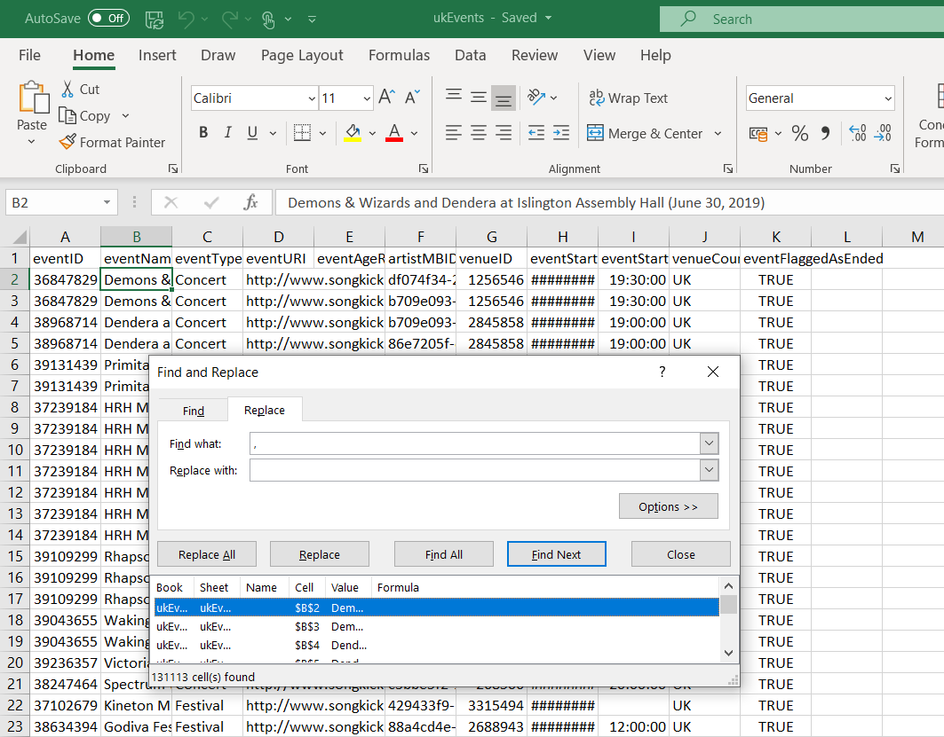

*Figure 2: Microsoft Excel output showing the removal of 269,050 commas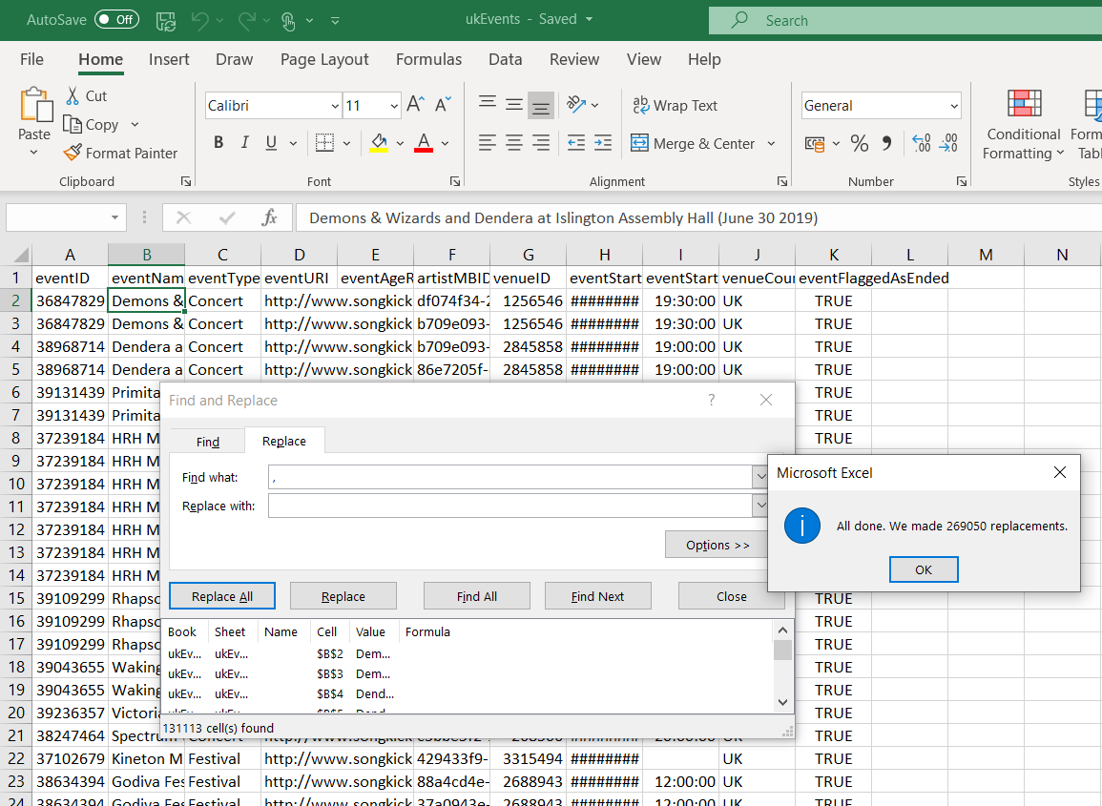*

*Figure 3: Microsoft Excel output showing eventAgeRestriction record with a double quotation mark (“) and showing 74 cells with double quotation marks*

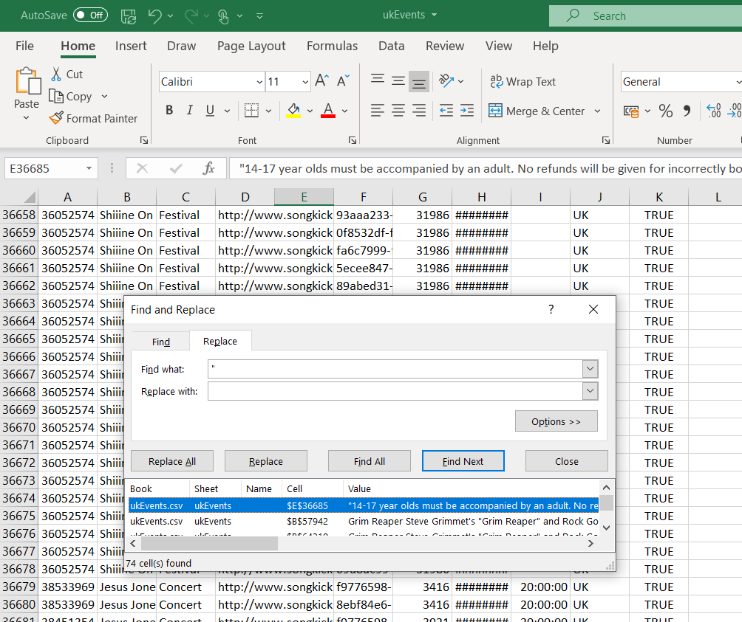

*Figure 4: Microsoft Excel output showing removal of 147 double quotation marks (“)